NATIONAL CARE HOME OPEN DAY
MEXICAN WAVE PLAN
On Friday 20th June 2014, thousands of the UK's care homes will be opening their doors together to the public for National Care Home Open Day.
Every care home involved in the National Care Home Open Day is invited to take part in the International NCHOD Mexican Wave!
The Mexican Wave
Care homes in each county in England, Scotland, Wales and Northern Ireland will be allocated a precise moment on National Care Home Open Day when they should take part in the Mexican wave.
At the right moment, residents and staff will do a Mexican wave while being filmed and having photos taken. These will be uploaded to a shared folder online so they can be posted on the NCHOD Twitter feed, to show the world the largest continuous Mexican wave in history!
Uploading photos and videos of your Mexican wave
Once you have completed the Mexican wave in your home, please upload your photos and videos as quickly as possible so everybody can track the wave online as it travels up the country.
- Connect your device (camera or cameraphone) to your computer

- Go online to: https://onedrive.live.com/

- Sign in using these details:
Username: NCHOD14@hotmail.com
Password: Mexicanwave
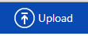
(click sign in when you have entered the details)
- At the top left hand of the page, click the Upload button:

- A dialog box will open where you can find your device (camera or camera phone)
  - This will usually be in: 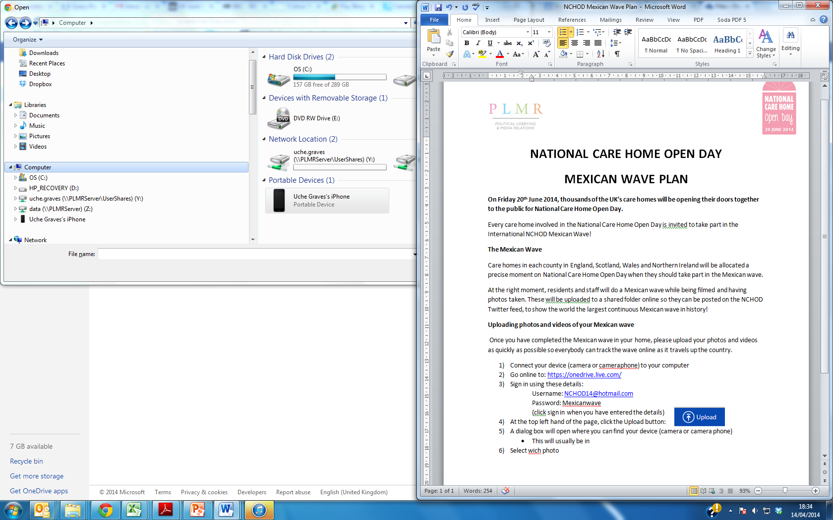
  - Then in:
  - (This may vary from computer to computer)

- Select which photos and videos you would like to upload by double clicking them. They will then upload
- Repeat steps 4 to 6 for each photo or video you would like to upload

- Once photos and videos are uploaded, create a new folder for your home by clicking and holding Create and selecting Folder

- A dialog box will open to name the folder. Enter your care home operator (eg Barchester) followed by your home name (eg Alice Grange) followed by your county (eg Norfolk)

- Drag the photos and videos you have uploaded into the folder you have created
Your photos and videos will then be tweeted from the NCHOD Twitter Feed:
